HACKATHON PROJECT REPORT
INTER-PROCESS CHAT
APPLICATION USING IPC
A Local Web Interface, C HTTP Backend and FIFO-Based Terminal Chat

Project Detail | Information
Team ID | G-10
Team Member 1 | T. Meghana Sai — 2520030245
Team Member 2 | K. Akshitha Reddy — 2520030233
Course | Operating Systems
Execution Environment | Linux / Ubuntu
Languages | C, HTML, CSS, JavaScript
IPC Mechanism | Linux Named Pipes (FIFOs)
HTTP Library | libmicrohttpd
Submitted To | [Add faculty name]
Institution / Department | [Add institution and department]

ABSTRACT
The Inter-Process Chat Application Using IPC is an Operating Systems project developed to demonstrate local message exchange through two practical communication paths. The first path is a browser-based chat interface built with HTML, CSS, and JavaScript. The user enters a name and a text message in the website and submits it using the Send button. JavaScript sends the submitted information as a JSON HTTP POST request to a C backend running locally on port 8081. The backend is implemented using the libmicrohttpd library, handles the /message endpoint, extracts the sender name and message text from the request, and prints the received message in the backend terminal. The website itself is served locally on port 8000.
The second path is a terminal-based chat application written in C. Two client instances, identified as User 1 and User 2, run in separate Ubuntu terminal tabs. The clients use two Linux named pipes, also called FIFOs, to transfer messages in opposite directions. One FIFO is used for one direction of communication and the second FIFO is used for replies. This arrangement demonstrates how separate local processes can exchange data through file descriptors and Linux system calls such as mkfifo(), open(), read(), write(), and close().
Testing performed during development showed that a message submitted through the website appears in the C backend terminal. The separate terminal chat clients were also used to exchange messages between User 1 and User 2. These are currently two separately demonstrated paths. Automatic forwarding of a website-submitted message into User 2's FIFO chat session has not been confirmed as working and is therefore described as a limitation and future enhancement rather than a completed feature.
The project connects Operating Systems concepts with practical C programming and basic web development. It provides experience with HTTP request handling, local services, FIFO communication, file descriptors, terminal-based testing, and preparation of a live demonstration. The application is intended for a controlled local Linux environment and is not presented as a production-ready or internet-wide messaging service.

TABLE OF CONTENTS
Abstract
1. Introduction
2. Problem Statement
3. Motivation and Need
4. Objectives
5. Scope of the Project
6. Background and Technical Concepts
7. System Requirements
8. System Architecture
9. Working Methodology
10. Technologies Used
11. Important Functions and Interfaces
12. Implementation Details
13. Compilation and Execution
14. Testing and Validation
15. Results and Discussion
16. Advantages
17. Limitations
18. Future Enhancements
19. Team Roles and Participation
20. Conclusion
References
Appendix A: Screenshot Checklist
Appendix B: Repository Contents

1. INTRODUCTION

1.1 Overview
An operating system manages the execution of programs and provides the environment in which processes are created, scheduled, and terminated. A process is a program in execution and normally has its own virtual address space. This separation is important for protection and reliability, but it also means that data created inside one process is not automatically available to another process. When two processes need to exchange information, an inter-process communication mechanism is required.
Inter-Process Communication, commonly called IPC, refers to operating-system mechanisms that support data exchange or coordination between independent processes. Depending on the use case, IPC can be implemented using pipes, named pipes, message queues, shared memory, signals, or sockets. Each mechanism has different properties relating to data transfer, synchronization, scope, and complexity. Understanding these mechanisms is an important part of an Operating Systems course because they show how software components cooperate while remaining separate execution units.

1.2 Project Overview
The project titled “Inter-Process Chat Application Using IPC” demonstrates messaging through a small local application. It combines a browser-based interface, a C HTTP backend, and a separate terminal chat program that uses named pipes. The web interface provides a familiar way to enter a username and a message. After the user presses Send, JavaScript submits the message to the local backend. The backend receives the request and displays the submitted name and message in its terminal, allowing the user to observe the communication between the browser and the C program.
The terminal chat component demonstrates IPC more directly. Two client instances run in different terminal tabs and behave as User 1 and User 2. The clients use the named FIFO paths /tmp/ipc_chat_one and /tmp/ipc_chat_two. Each FIFO provides a one-way communication path, and the pair of FIFOs enables messages and replies to move in opposite directions. The client code opens FIFO file descriptors, reads messages from the incoming channel, and writes typed messages to the outgoing channel.

1.3 Why This Project Is Useful
A chat application is an understandable example for learning IPC because the result of a message transfer is visible. A user types a message, a communication channel carries it, and another endpoint displays it. The same simple interaction can be used to explain file descriptors, blocking input/output, data buffers, system calls, and cleanup. The website part also shows how a browser interface can communicate with a local service through an HTTP request, while the terminal part focuses on process-to-process communication through FIFOs.

1. INTRODUCTION (CONTINUED)

1.4 Project Environment
The project was developed and tested in an Ubuntu/Linux environment. The source code is stored in a project directory named IPC_Chat_Application. The web interface consists of index.html, style.css, and script.js. A Python static HTTP server is used to serve the website locally on port 8000. The C backend source is stored in backend/server.c and uses libmicrohttpd to listen on port 8081. The terminal chat source is stored in backend/chat.c and is compiled into an executable named backend/chat.
These components are started as separate processes. The web server serves static files, the C backend handles browser requests, and the terminal clients exchange data through FIFO files. This setup makes the components easy to demonstrate individually in a controlled environment. It also makes it possible to inspect the output of each process in its own terminal window.

1.5 Project Boundaries
The current prototype should be understood according to the behavior that was actually tested. Website messages are submitted to the C backend and printed in the backend terminal. Separately, User 1 and User 2 exchange messages through the FIFO-based terminal chat. Automatic forwarding from the website backend into User 2's active terminal chat has not been verified. Therefore, the project does not claim that all components form one fully integrated end-to-end chat path.
The system is a local demonstration and does not currently provide user authentication, encryption, permanent message storage, or general internet connectivity. These are outside the verified implementation scope. The project focuses on demonstrating basic browser-to-backend messaging and Linux FIFO-based IPC, documenting the implementation, and showing the observed behavior during a live hackathon demonstration.

1.6 Organization of the Report
This report introduces the problem and project objectives, explains IPC and named pipes, lists the software requirements, describes the system architecture and implementation, and provides setup and execution commands. It then documents the tests performed, the results observed, the current limitations, and possible future improvements. Screenshot placeholders are included so that actual evidence from the user's running system can be inserted before submission.

2. PROBLEM STATEMENT
Independent processes normally operate in separate address spaces. A message stored in one process's memory cannot be directly accessed by another process unless the operating system or an explicit communication mechanism provides a way to transfer it. For an application that has two users running as separate terminal processes, a communication path is needed to transfer messages in one direction and replies in the other.
The project addresses this learning problem by implementing a local two-user terminal chat using Linux named pipes. It also adds a browser-based interface and a C HTTP backend to demonstrate a second messaging path: a website submits a message to the backend, and the backend prints the message to its terminal. These two paths provide practical examples of data transfer across software components, while remaining separate in the current verified version.

2.1 Problem Definition
Develop and demonstrate a local messaging prototype that (1) accepts a username and message through a browser interface, (2) transmits the website message to a C HTTP backend and displays the received content in the backend terminal, and (3) allows two separate terminal chat clients to exchange text messages through Linux FIFO files. The application should provide clear visible output and should be executable through documented commands in Ubuntu/Linux.

2.2 Need for a Communication Mechanism
Without a communication mechanism, two processes cannot reliably exchange information simply by using variables that belong to their separate memory spaces. A defined channel is required. In this project, HTTP is used between the browser and the backend service, while named pipes are used between the terminal chat processes. This distinction is important: HTTP requests and FIFO reads/writes are different communication methods, even though both carry text messages.
[ SCREENSHOT PLACEHOLDER: Problem demonstration / initial website ]
Optional: insert the clean website interface to show the user-facing part of the problem.

3. MOTIVATION AND NEED
The main motivation for this project is to convert the theoretical concept of Inter-Process Communication into an observable working program. Topics such as processes, file descriptors, system calls, pipes, and synchronization can feel abstract when learned only from notes. A chat example makes these ideas easier to understand because the input and output can be observed directly.
The terminal chat also demonstrates why a communication channel must be selected and opened correctly. The clients need to agree on the FIFO paths and on which path is used for sending versus receiving. The operating system provides the underlying FIFO mechanism, while the application defines how the bytes are interpreted as messages. This creates an opportunity to learn about input/output behavior and the importance of checking return values from system calls.
The website component was included to make the project easier to interact with and to show how frontend code can send data to a C service. The HTML file defines the page, CSS controls its appearance, and JavaScript collects the form values and sends an HTTP POST request. The backend handles the request and prints the result in the terminal. This makes the backend's behavior visible to a person using the browser.

3.1 Educational Value
- Connects operating-system concepts with visible message transfer.
- Provides practice with C, Linux system calls, and file descriptors.
- Shows the difference between a browser HTTP request and local FIFO-based IPC.
- Provides a practical environment for testing multiple processes in separate terminals.
- Encourages clear documentation, reproducible commands, and evidence-based reporting.

3.2 Practical Need
A small local prototype is useful for demonstrations because it does not depend on a remote messaging service or external account. The project can be started from the local project directory, and its outputs can be inspected in the browser and terminal windows. This makes it suitable for a controlled classroom or hackathon demonstration, provided the presenter explains which communication paths have been verified and which remain future work.

4. OBJECTIVES
The project was developed with the following objectives:
- To create a clean browser-based chat interface using HTML, CSS, and JavaScript.
- To accept a username and message from the website form.
- To submit the message as JSON to a C HTTP backend through the POST /message endpoint.
- To display the submitted website message in the C backend terminal.
- To implement a terminal chat client that supports User 1 and User 2 roles.
- To use two Linux named pipes (FIFOs) to transfer terminal chat messages in opposite directions.
- To demonstrate the use of FIFO-related system calls such as mkfifo(), open(), read(), write(), and close().
- To run the website, backend, and terminal chat clients in a local Ubuntu/Linux environment.
- To test the two working communication paths separately and record the actual observed output.
- To prepare source code, a project report, a presentation, screenshots, and setup instructions for submission.

4.1 Expected Outcomes
The expected outcome is a local prototype in which the website loads in a browser, a submitted website message appears in the C backend terminal, and the two terminal chat clients exchange messages using FIFOs. The project also aims to provide understandable source files and commands so that another student or evaluator can reproduce the demonstrations. Full forwarding of website messages into the User 2 FIFO chat session is not included as a confirmed outcome in the current version.

4.2 Success Criteria
Criterion | Evidence to show
Website loads | Browser displays the IPC Chat interface at localhost:8000.
Backend receives website message | Backend terminal prints the submitted name and message.
Two terminal clients run | User 1 and User 2 show a connected state in separate terminals.
FIFO message transfer | A message sent from one terminal appears at the other terminal, and a reply can be sent.
Reproducibility | The project can be restarted using documented local commands.

5. SCOPE OF THE PROJECT

5.1 Included Scope
The implemented and demonstrated scope includes the following elements:
- A local web interface containing a username field, message input, send button, and message display area.
- JavaScript code that submits a message to the local C HTTP backend.
- A C backend that receives POST /message requests and prints the submitted message.
- Two terminal chat client roles, selected with command-line arguments 1 and 2.
- Two named FIFO paths used for the terminal chat's outgoing and incoming messages.
- Local compilation and execution using GCC and Ubuntu/Linux tools.
- Manual testing and screenshot evidence for the demonstrated features.

5.2 Excluded or Unverified Scope
- Automatic forwarding of website-submitted messages to User 2's terminal has not been verified.
- Internet-wide chat between computers on different networks is not implemented.
- Authentication, user accounts, encryption, and production security controls are not provided.
- Permanent message history is not implemented; backend storage is temporary in-memory storage.
- Multi-user group chat beyond the two terminal roles is outside the current demonstrated scope.

5.3 Intended Users
The primary users are students, instructors, and hackathon evaluators who want to observe how messages can be transferred between software components. The browser interface provides a simple input mechanism, while the separate terminal clients demonstrate operating-system IPC concepts directly. The application is intended for learning and demonstration rather than as a production messaging platform.

6. BACKGROUND AND TECHNICAL CONCEPTS

6.1 Process
A process is an instance of a program that is being executed. The operating system maintains information about each process and manages its execution, memory, open file descriptors, and scheduling. Two running instances of a program can behave as separate processes even when they execute the same source code. In this project, the two terminal chat clients run independently and are assigned different user roles.

6.2 Inter-Process Communication
IPC refers to operating-system facilities that allow processes to exchange information or coordinate their activities. The correct IPC mechanism depends on factors such as whether the processes are related, whether data must be retained, the amount of data, and the required synchronization. IPC can be implemented using pipes, FIFOs, message queues, shared memory, signals, or sockets. This project focuses on named pipes for terminal chat.

6.3 Named Pipes (FIFOs)
A named pipe, also called a FIFO, is a special filesystem object that provides a communication channel. Unlike an unnamed pipe, a FIFO has a pathname that separate processes can use to locate it. Processes open the FIFO and use file descriptors to read or write data. The FIFO itself is not a permanent message database; it is a communication channel through which data passes between endpoints.

6.4 Two-FIFO Design
A single FIFO is normally a one-way byte stream. To support messages in both directions, the project uses two FIFO paths. One path carries messages from User 1 toward User 2, and the other carries messages from User 2 toward User 1. Each client selects its incoming and outgoing paths according to the role argument. This design makes the direction of communication explicit and easier to explain.
FIFO path | Purpose in terminal chat
/tmp/ipc_chat_one | One direction of message transfer, as selected by the client role.
/tmp/ipc_chat_two | The opposite direction of message transfer, as selected by the client role.

6.5 File Descriptors
An open FIFO is represented by a file descriptor, which is an integer used by system calls to identify the open communication endpoint. The application passes these descriptors to read() and write() to receive and send data. Descriptors should be closed when they are no longer required. Correct descriptor handling helps prevent resource leaks and supports clean termination.

6. BACKGROUND AND TECHNICAL CONCEPTS (CONTINUED)

6.6 Relevant System Calls
Call | General purpose | Use in this project
mkfifo() | Create a named pipe. | Create the two FIFO paths if missing.
open() | Open a file or FIFO and return a descriptor. | Open incoming and outgoing FIFO channels.
read() | Read bytes from a descriptor. | Receive terminal chat messages.
write() | Write bytes to a descriptor. | Send terminal chat messages.
close() | Release an open descriptor. | Close FIFO descriptors on exit.
pthread_create() | Create a POSIX thread. | Only include this explanation if the final chat.c uses a receiver thread.

6.7 HTTP and the Browser-to-Backend Path
HTTP is a request-response protocol used by the browser and backend in the web component. The frontend JavaScript uses fetch() to submit a POST request to the backend's /message route. The request includes a JSON object containing the sender name and message text. The C backend reads the request body, extracts the expected values, and returns a text response. The frontend checks the response and then displays the submitted message in the web page.

6.8 CORS
The web page is served on port 8000 while the C backend listens on port 8081. Because these are different origins, the browser may perform a CORS preflight request before sending the POST request. The backend includes Access-Control-Allow-Origin, Access-Control-Allow-Methods, and Access-Control-Allow-Headers response headers to permit the local frontend to make the request. These headers enable browser access; they do not themselves transfer messages to the FIFO clients.

6.9 Difference Between the Two Paths
Feature | Website-to-backend | Terminal FIFO chat
Input | Browser form | Terminal keyboard
Communication method | HTTP POST with JSON | Linux named pipes and file descriptors
Receiver | C HTTP backend | Other terminal chat client
Visible output | Backend terminal and website UI | Other user's terminal
Current status | Tested working | Tested working
Website-to-User-2 forwarding | Not confirmed | Not applicable to the separate terminal-only test

7. SYSTEM REQUIREMENTS

7.1 Hardware Requirements
- A computer capable of running Ubuntu/Linux or an Ubuntu environment.
- A keyboard for entering terminal and website messages.
- A display capable of showing a browser and multiple terminal windows during the demo.
- Enough memory and storage to run the compiler, local servers, and editor.

7.2 Software Requirements
- Ubuntu/Linux terminal environment.
- GCC compiler for building the C programs.
- Python 3 for serving the static website.
- libmicrohttpd development package for compiling the C HTTP backend.
- pkg-config for retrieving compiler and linker flags for libmicrohttpd.
- A modern browser such as Firefox or Chrome.
- A text editor such as nano or Visual Studio Code.

7.3 Project Directory Structure
The current project directory is ~/IPC_Chat_Application. The principal files are organized as follows:
IPC_Chat_Application/
├── index.html
├── style.css
├── script.js
└── backend/
├── server.c
├── server
├── chat.c
└── chat
The .c files are the source code. The server and chat entries without the .c extension are compiled executables generated from their corresponding source files.

7.4 Required Services
The static website server and the C HTTP backend must be running while demonstrating the browser-to-backend path. The two terminal chat clients are started separately when demonstrating FIFO-based IPC. Each long-running service should remain open in its own terminal so that its output can be inspected.

8. SYSTEM ARCHITECTURE

8.1 High-Level Architecture
The application contains two communication paths. The first path begins with the browser interface. The user enters a name and message; JavaScript submits the data to the C HTTP backend; and the backend prints the received content to its terminal. The second path consists of User 1 and User 2 terminal clients that exchange messages through two named pipes. The paths are demonstrated independently in the current version.
LIST OF ALL FILES
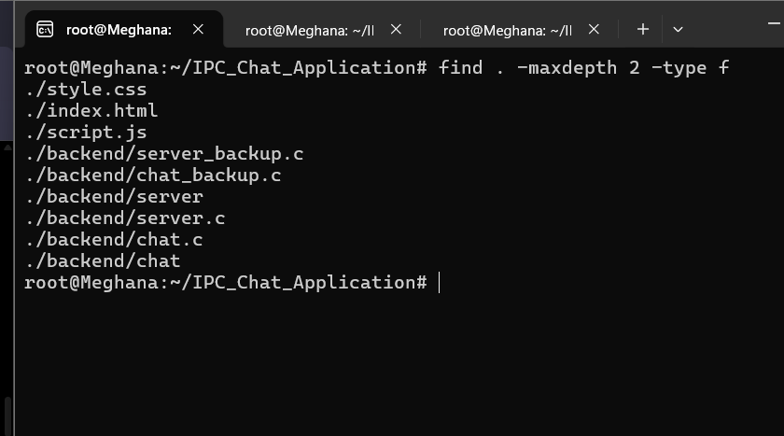

8.2 Frontend Component
The frontend is made up of three files. index.html provides the structure of the page, including the title, username field, message area, and form. style.css defines the layout, colors, spacing, and visual appearance. script.js attaches a submit handler to the form, reads the username and message, checks that the fields are not empty, and sends the values to the backend. If the request succeeds, the page adds the message to the displayed conversation area.

8.3 C HTTP Backend Component
The C backend is implemented in backend/server.c using libmicrohttpd. It listens on port 8081. The GET / route returns a basic health response, while POST /message processes the submitted chat content. The handler collects the request body, extracts the name and message from the expected JSON structure, stores the message in a temporary in-memory array, and prints it using printf(). It then returns a text response to the browser.

8.4 FIFO Chat Component
The terminal client is implemented in backend/chat.c. It accepts the command-line argument 1 or 2 to choose the user role. The client creates the two FIFO paths if they do not already exist, selects an outgoing FIFO and an incoming FIFO based on the role, and opens the channels. It uses write() to send typed messages and read() to receive data from the opposite channel. The exact receiver/concurrency behavior should be described from the final saved source code.

8.5 Architecture Limitation
The backend currently prints website messages, and the FIFO terminal clients exchange messages with one another. Automatic forwarding from the web backend into the active User 2 terminal chat has not been verified. The architecture diagram must therefore show two paths rather than a single connected chain from the website to User 2.

9. WORKING METHODOLOGY

9.1 Website Message Submission
- Navigate to the project directory.
- Start the static server with python3 -m http.server 8000.
- Start the C HTTP backend in a separate terminal using ./backend/server.
- Open http://localhost:8000 in the browser.
- Enter the username and a sample message.
- Click Send; script.js submits the form values as JSON to http://localhost:8081/message.
- The backend receives the POST request, extracts the sender and text, and prints the message in its terminal.
- The browser displays the submitted message when it receives a successful response.

WEBSITE UI
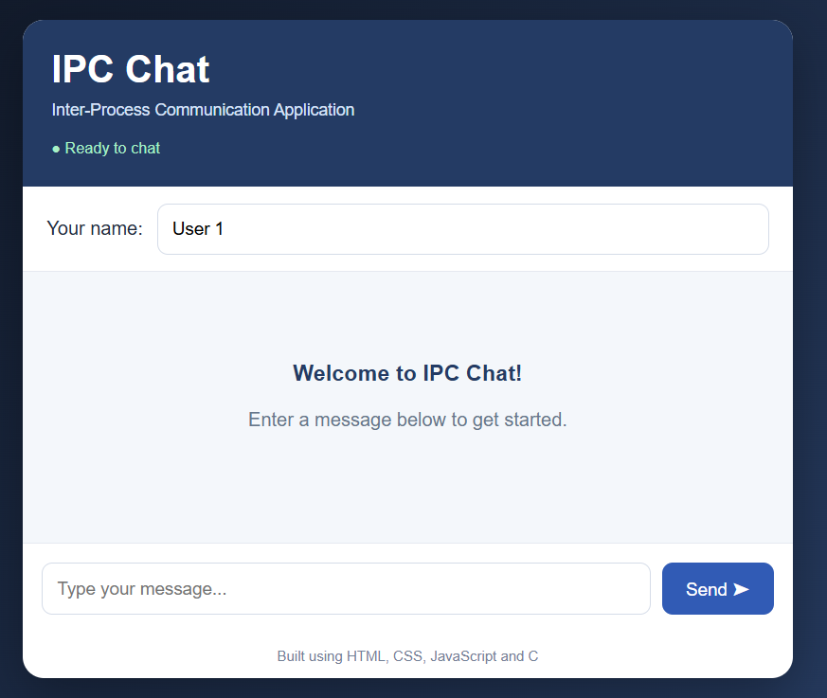
WEBSITE MESSAGE PROCESSING
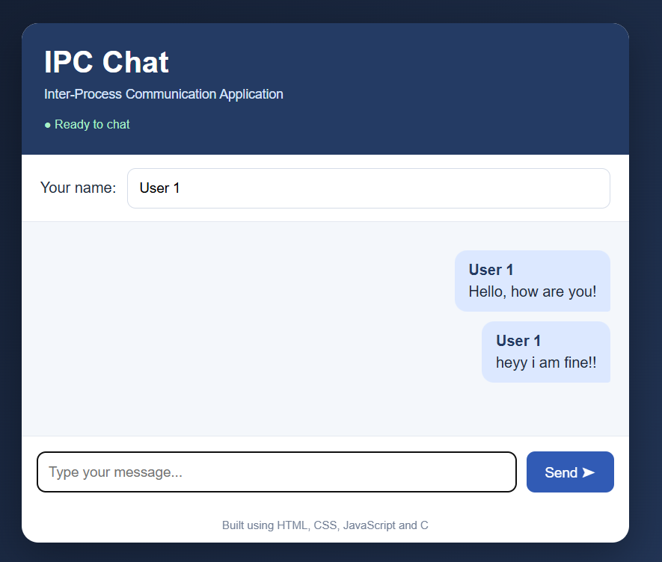

9.2 Terminal FIFO Message Exchange
- Open a terminal tab and change directory to ~/IPC_Chat_Application.
- Start the first client using ./backend/chat 1.
- Open another terminal tab and start the second client using ./backend/chat 2.
- Wait until both clients display the connected message.
- Type a message in one client and press Enter.
- Observe the message in the other terminal, then send a reply.
- Repeat with another message if time permits.
- Type /quit in each client to end the chat.

USER 1 TERMINAL
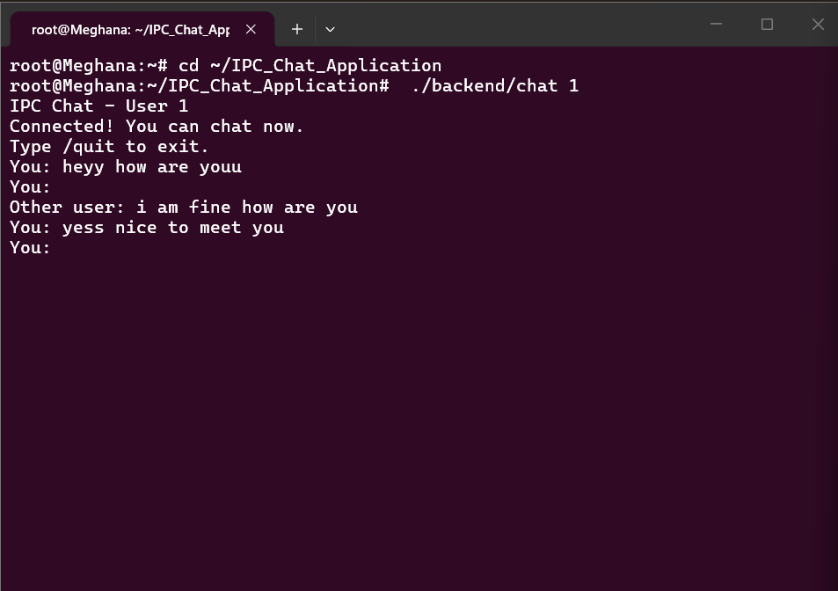
USER 2 TERMINAL
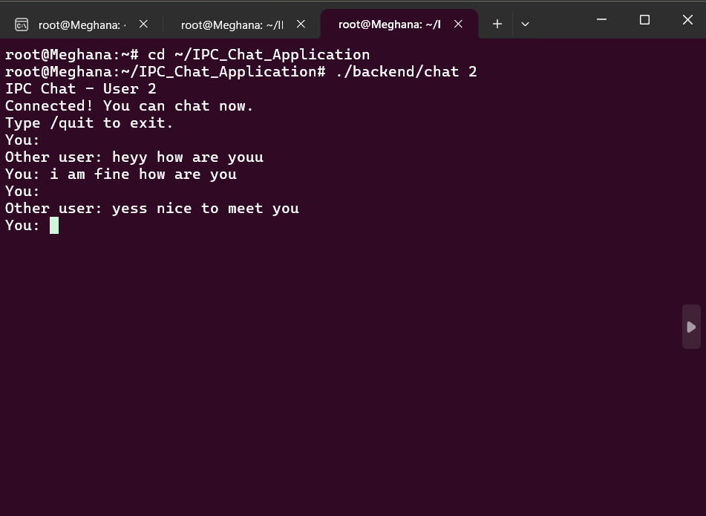

9.3 Live Demonstration Sequence
During the hackathon demonstration, the presenter can first show the website and send a short message. The C backend terminal is then brought into view to show that the same name and message were received. Next, the presenter shows two Ubuntu terminal tabs running User 1 and User 2 and exchanges a message and reply. The presenter should explain that these are two separately working communication paths in the current prototype.

10. TECHNOLOGIES USED
Technology | Description | Role in this project
C | Compiled programming language. | Implements the HTTP backend and FIFO terminal chat clients.
HTML | Markup language for web page structure. | Defines the chat page and input controls.
CSS | Stylesheet language. | Controls the web interface layout and appearance.
JavaScript | Browser-side programming language. | Reads input and submits a JSON HTTP request.
Ubuntu/Linux | Operating system environment. | Runs the backend, web server, terminal clients, and FIFO objects.
GCC | C compiler. | Builds server.c and chat.c into executables.
libmicrohttpd | C library for HTTP services. | Handles requests to the C backend.
Python 3 http.server | Simple local static-file server. | Serves index.html, style.css, and script.js on port 8000.
Named pipes (FIFOs) | Local IPC mechanism. | Carries messages between User 1 and User 2 terminal processes.
POSIX threads | Threading interface, if used in final source. | Supports concurrent message receiving if the final chat client uses pthreads.

10.1 Why These Technologies Were Selected
C and Linux system calls are suitable for demonstrating operating-system concepts directly. FIFOs are a simple local IPC mechanism that can be inspected and opened by separate processes. HTML, CSS, and JavaScript make the website easy to use without requiring a complex frontend framework. libmicrohttpd allows the backend to be implemented in C while handling HTTP requests. GCC provides a straightforward way to compile the source files, and Python's built-in HTTP server is sufficient for serving static frontend files during a local demonstration.

10.2 Role of Each Project File
File | Responsibility
index.html | Page structure, username field, message input, Send button, and message display area.
style.css | Colors, spacing, layout, and responsive visual styling.
script.js | Form validation, HTTP POST request, response handling, and displaying the message.
backend/server.c | C HTTP server, request handling, message extraction, and backend terminal output.
backend/chat.c | User 1/User 2 role selection and FIFO-based terminal chat.

11. IMPORTANT FUNCTIONS AND INTERFACES
Function / interface | Purpose | Project context
mkfifo() | Creates a named pipe if the path does not exist. | Prepares the two FIFO endpoints for terminal chat.
open() | Opens a FIFO and returns a file descriptor. | Opens the incoming and outgoing FIFO paths.
read() | Reads bytes from an open descriptor. | Receives data from the other terminal client.
write() | Writes bytes to an open descriptor. | Sends a terminal chat message.
close() | Closes an open descriptor. | Releases FIFO descriptors when a client exits.
fgets() | Reads a line from standard input. | Accepts a typed terminal message.
fetch() | Browser API for making HTTP requests. | Submits the website message to the C backend.
POST /message | HTTP endpoint implemented by the backend. | Receives the website name and message.
MHD_start_daemon() | Starts a libmicrohttpd HTTP server. | Starts the C backend on port 8081.
pthread_create() | Starts a POSIX thread. | Mention only if this function exists in the final saved chat.c.

11.1 File Descriptor Usage
After a FIFO is opened, the returned file descriptor is used as an argument to read() or write(). The application must use the correct descriptor for each direction. A client selects its outgoing FIFO for messages typed locally and its incoming FIFO for messages sent by the other user. The program also closes descriptors during cleanup. When explaining the code, use the actual variable names and control flow present in the final source files.

11.2 HTTP Request Handling
The website sends a POST request with a JSON content type. The C backend collects the request body and searches for the expected name and message fields. After processing the request, it returns a text response and includes CORS headers needed by the local browser frontend. The current parser is intended for simple test messages and should not be described as a complete general-purpose JSON parser.

12. IMPLEMENTATION DETAILS

12.1 Web Interface Implementation
The website interface is built using standard frontend technologies. The HTML page defines a chat container, heading, username field, message area, and message form. CSS gives the interface its dark blue background, white content area, rounded corners, and clear input controls. JavaScript listens for form submission, prevents a full page reload, reads the name and message, and stops if either field is empty.
Once the values are valid, JavaScript sends a request to http://localhost:8081/message. The request uses the POST method, the Content-Type header application/json, and JSON.stringify() to serialize the name and message. If the backend returns a successful response, the script removes the welcome text if present, adds a message element to the page, clears the input field, and logs the backend response. If the request fails, an alert reports the backend connection error.

12.2 C Backend Implementation
The backend source file backend/server.c includes libmicrohttpd and standard C headers for string handling, memory allocation, and input/output. The server is configured to listen on port 8081. The root route responds with a short health message. The POST /message route accumulates request body data, extracts the name and message strings from the expected JSON format, stores the values in a fixed-size in-memory array, prints the sender and message, and sends a response back to the browser.
CORS headers are added to responses so the browser page served from port 8000 can make requests to the backend on port 8081. The backend also handles an OPTIONS request for the browser's preflight. The implementation is intended for a local demonstration with simple text input. Its basic JSON parsing is not robust against all possible escaped characters, and the in-memory message array does not persist messages after the process stops.

BACKEND TERMINAL
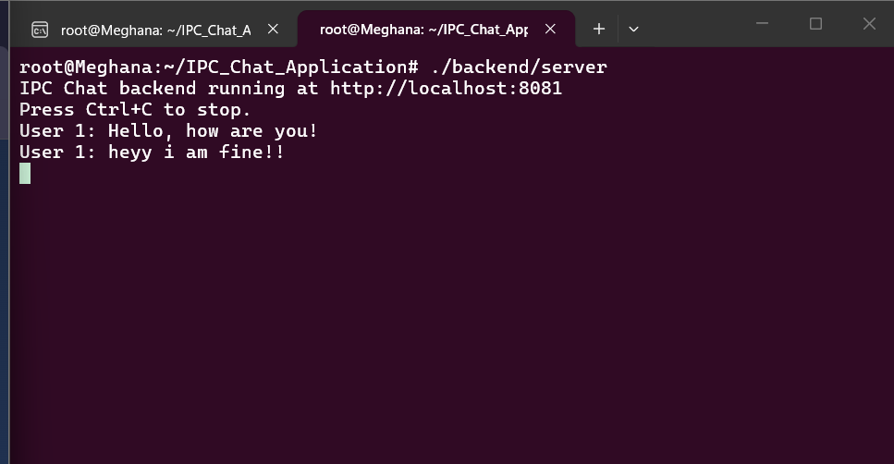

12.3 FIFO Chat Implementation
The FIFO client source is backend/chat.c. The program validates that the user passes either 1 or 2 as the role argument. It sets outgoing and incoming FIFO paths based on the selected role and creates both FIFO paths if they are missing. It opens the incoming and outgoing paths and then enters a loop that accepts a message from the terminal. A message is written to the outgoing FIFO, and incoming data is read from the other FIFO according to the current source implementation.
The FIFO chat is a separate terminal demonstration. Its successful test consists of starting both clients in separate terminal tabs, sending a message from one client, observing it in the other client, and then sending a reply. The exact behavior of receiving while typing depends on the final version of the client source; the report should not claim a concurrency mechanism that is absent from that source.

USER 1 AND USER 2
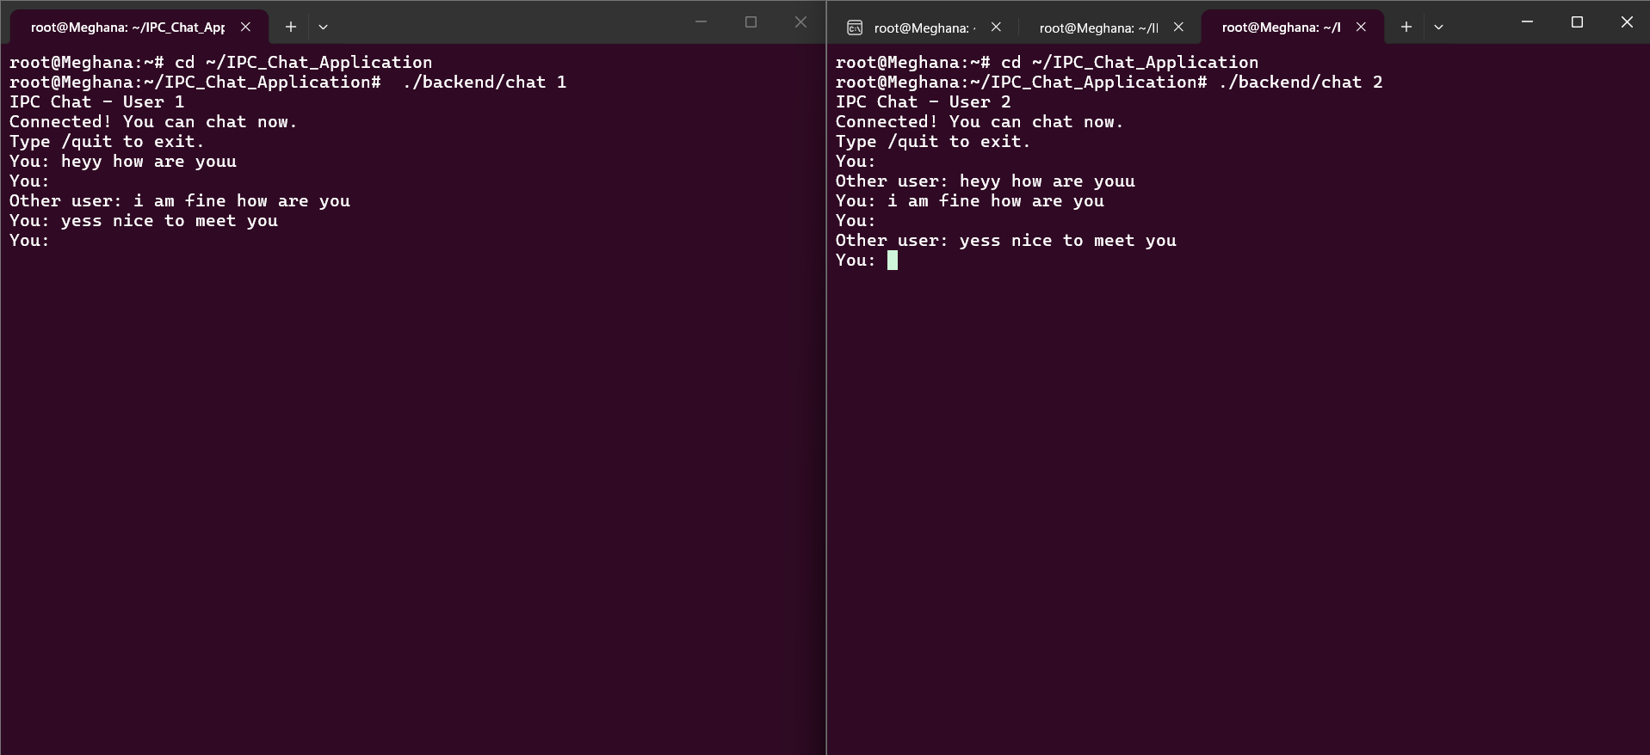

13. COMPILATION AND EXECUTION

13.1 Project Directory
cd ~/IPC_Chat_Application
pwd
ls
The pwd command should show the IPC_Chat_Application directory. The ls command should show index.html, style.css, script.js, and the backend directory.

13.2 Start the Website Server
cd ~/IPC_Chat_Application
python3 -m http.server 8000
Keep this terminal running. Open the browser and navigate to http://localhost:8000.

13.3 Compile and Start the C HTTP Backend
cd ~/IPC_Chat_Application
gcc -Wall -Wextra backend/server.c -o backend/server $(pkg-config --cflags --libs libmicrohttpd)
./backend/server
Keep the backend terminal running. If the server reports that port 8081 is already in use, do not launch another copy on the same port; use the existing server process or stop it before restarting.

13.4 Compile and Start the FIFO Chat Client
cd ~/IPC_Chat_Application
gcc -Wall -Wextra backend/chat.c -o backend/chat -pthread
Run the compilation command if the source code has changed or the executable needs to be rebuilt. Open two separate terminal tabs and run one command in each:
./backend/chat 1
./backend/chat 2
The terminal clients should be tested together. Type a message in one client and verify that it appears in the other. Then send a reply from the second client.

13.5 Shutdown
Use /quit in the terminal chat clients to end their sessions. Stop the static web server or C backend with Ctrl+C only when the demonstration is complete. If the application is restarted later, run the required commands again in separate terminals. Source files remain saved in the project directory.

14. TESTING AND VALIDATION
Testing was performed manually by running the website, backend, and terminal chat clients in the local Ubuntu/Linux environment. The goal was to confirm the visible behavior of each communication path. The results below reflect the behaviors reported during development. Website-to-User-2 automatic forwarding is not marked as successful because it has not been verified.
Test ID | Test action | Observed result | Status
T1 | Open http://localhost:8000 | Website interface loaded in the browser. | Passed in development
T2 | Send a website message | Message appeared in the C backend terminal. | Passed in development
T3 | Start User 1 and User 2 in separate terminals | Both clients reached the connected state. | Passed in development
T4 | Exchange messages between User 1 and User 2 | Terminal clients exchanged messages. | Passed in development
T5 | Send a website message and check User 2 terminal | Automatic forwarding was not confirmed. | Not verified / limitation
T6 | Close and reopen the environment, then restart services | Project files remained in the project directory; services must be restarted. | Manual restart procedure

14.1 Website-to-Backend Test
The browser was opened at the local website address and a sample message was entered. The C backend terminal displayed the submitted name and message. This verifies the browser-to-backend request path for the tested input. The website also displayed the submitted message in the interface after receiving a successful backend response.

14.2 FIFO Chat Test
Two terminal tabs were used to start User 1 and User 2. Messages were exchanged between the clients through the FIFO-based terminal chat. The test demonstrates local process-to-process communication. Capture both terminal outputs so that the message sent by one user and received by the other can be seen clearly.

14.3 Testing Limitations
The web backend's attempt to write to a FIFO did not reliably establish automatic delivery to User 2. Therefore, the report distinguishes the verified website-to-backend behavior from the verified terminal FIFO behavior. Any later integration should be tested independently before being described as completed.

15. RESULTS AND DISCUSSION

15.1 Results Achieved
- The website interface loads locally in a browser.
- The user can enter a name and message and submit the form.
- The C HTTP backend receives the website request and prints the message in its terminal.
- User 1 and User 2 can run as separate terminal chat clients.
- The terminal chat clients exchange messages using named pipes.
- The project can be demonstrated through visible browser and terminal output.

15.2 Discussion
The project demonstrates two communication mechanisms in a single project folder. The website-to-backend path uses HTTP and JSON, while the terminal chat path uses FIFO file descriptors. These mechanisms have different endpoints and different responsibilities. The browser does not directly read a FIFO; it sends an HTTP request to the backend. The terminal clients open FIFO paths to communicate with each other. This separation is why website-to-backend success does not by itself prove website-to-User-2 delivery.

15.3 Evidence-Based Reporting
For evaluation, screenshots should show actual output from the final code rather than illustrative or expected output. The website screenshot should show the submitted message, and the backend screenshot should show the same message. The terminal chat screenshots should show User 1 and User 2 exchanging a message. Together, these provide evidence for the specific features that were tested.

16. ADVANTAGES
- Combines a browser-based interface with a C backend and a terminal IPC demonstration.
- Demonstrates HTTP request handling and Linux FIFO communication using visible outputs.
- Uses C and Linux system calls to illustrate operating-system concepts.
- Does not require an external messaging service for the local demonstration.
- Provides source files that can be compiled and executed from a documented project directory.
- Can be extended with improved input validation, persistent storage, and more reliable integration.

16.1 Learning Outcomes
Through this project, the team gains practical experience in connecting a frontend to a backend, compiling C programs, working with local HTTP services, using file descriptors, and transferring messages through named pipes. The testing process also reinforces the importance of distinguishing between a feature that is implemented, a feature that has been tested, and a feature that is only planned for future development.

17. LIMITATIONS

17.1 Current Functional Limitations
- Website messages are displayed by the C backend but automatic forwarding to User 2's FIFO chat has not been confirmed.
- The terminal chat is intended for local processes running in the same Linux environment.
- The backend uses simple string-based extraction for the expected JSON input and is not a full JSON parser.
- Message storage in the backend is temporary and held in memory.
- The application does not currently provide user authentication or encrypted messaging.

17.2 Operational Considerations
The static web server and C backend must be running for the browser-to-backend demonstration. The terminal clients must be started separately for FIFO chat. If port 8000 or port 8081 is already in use, a second service cannot bind to that same port. The user should check the existing terminal before starting another copy. FIFO opening and reading behavior can also depend on whether the other endpoint is running and how the client handles input/output.

17.3 Security and Reliability
The prototype is intended for a controlled local demonstration. It should not be treated as a secure public chat service. A production version would require robust JSON parsing, validation, authentication, access controls, careful concurrency handling, and reliable message delivery. These are acknowledged limitations rather than claimed features.

18. FUTURE ENHANCEMENTS
The following improvements could extend the current prototype after the hackathon demonstration:
- Implement reliable asynchronous forwarding from the C HTTP backend to the FIFO chat receiver.
- Use a proper JSON parser instead of manual string extraction.
- Add persistent message history using a file or database.
- Add timestamps and improved sender identification.
- Improve connection status, reconnection behavior, and error messages.
- Add a more structured build process such as a Makefile or build script.
- Add automated tests for message delivery, invalid inputs, and service startup errors.
- Introduce authentication and encryption if the project is expanded beyond a local learning environment.
- Support multiple users through a coordinator or a more flexible local communication architecture.

18.1 Priority Enhancement
The most direct next step is to connect the website backend and the FIFO chat with reliable asynchronous delivery. The backend must be able to deliver a website message to the receiving chat client without requiring the terminal user to enter another message first. That behavior should be implemented and tested before the project is described as a unified end-to-end chat application.

19. TEAM ROLES AND PARTICIPATION
Both team members should understand the overall problem statement, system architecture, technologies, and live demonstration. The table below is a suggested division and should be edited if the actual contributions differ.
Team member | Suggested responsibility
T. Meghana Sai — 2520030245 | Website interface, browser-to-backend testing, project integration, and live demonstration.
K. Akshitha Reddy — 2520030233 | FIFO terminal chat, IPC testing, documentation, and presentation preparation.

19.1 Topics Both Members Should Be Ready to Explain
- What Inter-Process Communication means and why it is needed.
- Why two named pipes are used for two-way terminal chat.
- What mkfifo(), open(), read(), write(), and close() do.
- How JavaScript sends a message to the C backend using HTTP POST and JSON.
- Why the website/backend path and terminal FIFO chat are described separately.
- What was tested successfully and what remains a limitation.

20. CONCLUSION
The Inter-Process Chat Application Using IPC provides a practical demonstration of local messaging through a web interface, a C HTTP backend, and a FIFO-based terminal chat. The website uses HTML, CSS, and JavaScript to collect and submit a message. The C backend, implemented with libmicrohttpd, receives the HTTP request and displays the submitted name and message in the backend terminal. Separately, User 1 and User 2 terminal clients use two Linux named pipes to exchange messages.
The development and testing process helped connect web request handling with operating-system concepts such as file descriptors, named pipes, system calls, and local process communication. The working website-to-backend path and the working terminal FIFO chat path can both be demonstrated to evaluators using actual screenshots and live output. Automatic delivery from the website to User 2 remains an identified limitation and future enhancement. By documenting the verified behavior accurately, the project provides a clear and reproducible learning prototype.

REFERENCES
- Linux man-pages project. Documentation for mkfifo(), open(), read(), write(), and close(). https://man7.org/linux/man-pages/
- GNU libmicrohttpd documentation. https://www.gnu.org/software/libmicrohttpd/
- Operating Systems course notes covering processes, file descriptors, pipes, named pipes, and inter-process communication.
- Project source files: index.html, style.css, script.js, backend/server.c, and backend/chat.c.

APPENDIX A: SCREENSHOT CHECKLIST
- Clean website interface.
- Website after sending a sample message.
- C backend terminal showing the same website message.
- User 1 terminal showing a sent message.
- User 2 terminal showing the received message and reply.
- Optional: successful compilation output and project directory listing.

APPENDIX B: REPOSITORY CONTENTS
Suggested repository structure:
IPC_Chat_Application/
├── index.html
├── style.css
├── script.js
├── backend/
│ ├── server.c
│ └── chat.c
├── README.md
├── docs/
│ ├── IPC_Chat_Application_Updated_Project_Report.docx
│ └── IPC_Chat_Application_Presentation.pptx
└── screenshots/
Only source files and documentation need to be committed. Compiled executables may be omitted and rebuilt from the README commands.

APPENDIX C: SCREENSHOT INSERTION GUIDE
Screenshot | Where to insert it | What it should prove
Website UI | Sections 9.1 and 12.1 | The browser interface loads and displays the submitted message.
Backend output | Sections 9.1, 12.2 and 14.1 | The C backend receives and prints the website message.
User 1 output | Sections 9.2 and 14.2 | User 1 sends a terminal message.
User 2 output | Sections 9.2 and 14.2 | User 2 receives and replies through FIFO IPC.
Project directory | Section 7.3 or appendix | The expected source files are present.

Before submission, replace every screenshot placeholder with actual evidence, complete institution/faculty details, and verify the report against the final saved source code.

